
www.ajbrui.org

Afr. J. Biomed. Res. Vol. 23 (January, 2020); 17- 23

Research Article
Phycosynthesis of Silver Nanoparticles Using Chlorella vulgaris Metabolites: Its Antibacterial, Anti-Biofilm and In-Vitro Cytotoxicity Potential and Effect of Optimized Conditions on Biosynthesis.

Salaam A.¹ , *Adebayo-Tayo B.² and Ajibade A.²
Departments of ¹Botany and ²Microbiology, Faculty of Science, University of Ibadan, Ibadan, Oyo state, Nigeria

ABSTRACT
The adverse effects of multidrug resistant and biofilm forming microbes on human health is of major concern; therefore a search for potential alternative in nanoparticles is required. Green phycosynthesis of silver nanoparticles (SNP) using The Clear Supernatant (TCS) of blue-green algae, Chlorella vulgaris (Cv) was investigated. The greenly synthesized Chlorella vulgaris TCS SNPs (CvTCSSNPs) were characterized using UV-Vis spectrophotometry, SEM, TGA, DLS, EDX and XRD. The antibacterial, antibiofilm and in vitro cytotoxicity against brine shrimp was evaluate. Colour change from light green to chocolate brown indicate CvTCSSNPs biosynthesis and surface Plasmon resonance peak was observed at 300 nm. CvTCSSNPs was 10 µm in size, spherical in shape, and can withstand high temperature without totally losing its weight. DLS shows the particle diameter average of 82.19 nm and 505.3 nm with a polydispersity index of 0.505. The EDX analysis confirmed a strong signal of silver element. The CvTCSSNPs had strong antibacterial activity and profoundly antibiofilm activity against Citrobacter sp., S. aureus ATCC 29213, E. coli ATCC 35218 and Pseudomonas aeruginosa ATCC 27853. CvTCSSNPs toxicity to Artemia salina (brine shrimp) LC₅₀ was 1256. 69 µg/mL, it was observed to be insignificant with the highest mortality rate at 2000 µg/mL and the lethality was dose dependent. pH 10, 37˚C, 40 mL extract, 5 mM AgNO₃ supported optimum CvTCSSNPs production. In conclusion, the phycosynthesized CvTCSSNPs had strong antibacterial and antibiofilm activity against the test pathogens. CvTCSSNPs may be used as safe and alternative to antibiotics against MDR biofilm producing pathogens.

Keywords: Chlorella vulgaris, Silver Nanoparticles, Characterization, antibacterial, anti-biofilm, pathogens, cytotoxicity.

*Author for correspondence: Email: bukola.tayo@gmail.com. Tel: +234-8035522409
Received: October 2018; Accepted: December, 2019

Abstracted by:
Bioline International, African Journals online (AJOL), Index Copernicus, African Index Medicus (WHO), Excerpta medica (EMBASE), CAB Abstracts, SCOPUS, Global Health Abstracts, Asian Science Index, Index Veterinarius


INTRODUCTION

Chlorella vulgaris a fresh water inhabitant belongs to the Kingdom Protista and Phylum Chlorophyta, a spherical unicellular microalga with 2-10 µm diameter (Yamamoto et al., 2004). The alga has simple cell structure with an emerald green colour and grass like odour as a result of high percentage of chlorophyll (Zaidi et al., 2018). Chlorella vulgaris is traditionally used in the treatment of asthma, gastritis, duodenal ulcer, constipation and in the prevention of the spread of cancer. It is known to aid immunity and reduce cholesterol level in the blood (Zaidi et al., 2018). Nanotechnology is one of the newest technologies that involves the use of nano-scientific innovations for the development of materials whose structural components size is usually less than 100 nm (Lloyd and Oremland 2006 ; Yadav et al., 2011; Rajabi et al., 2015).
The use of bacteria, fungi, algae or plant extract for the green synthesis of nanoparticles is on the increase and has emerged as alternative approach to chemical approach. Green route syntheses of silver nanoparticles have beneficiary effects such as simplicity, cost effectiveness; high yield and they are environmentally friendly over chemical approaches (Rai et al., 2009).
The use of natural biomaterials such as microbes (fungi, bacteria, viruses and algae) as reducing and capping agents is a simple alternative to complex chemical method of synthesizing nanoparticles. Green route approach of nanoparticle synthesis is the result of desire for cost effective, eco-friendly, biocompatible nanoparticles in place of physical and chemical approach (Sabri et al., 2016; Templeton et al., 2000). Stabilization of nanoparticles can be electrostatical and sterical. Electrostatic stabilization involved the coordination of anions including carboxylates, halides and others to metal particles in the formation of electrical double layer which creates repulsion between nanoparticles. Steric stabilization of nanoparticles involved the use of organic materials such as polymers and other bulk materials. The bulkiness of the materials prevents the diffusion of nanoparticle (Abou El-Nour 2010; Dumur et al., 2011). The bioactive metabolites from microorganisms can serve as stabilizing and reducing agents thereby providing a better biocompatibility for nanoparticles biosynthesis (Wang et al., 2017; Dakal et al., 2016; Dakal et al., 2016). Metal nanoparticles possess unique properties size and shape of the nanoparticles which was responsible for their wide applications (Abou El-Nour 2010; Rajeshkumar et al., 2017).
Characterization of the structural property silver nanoparticles production as a result of bioreduction of silver nitrate in aqueous solution using indirect method is usually achieved by UV-Vis spectroscopy (Raza et al., 2016). The antimicrobial activity of silver nanoparticles is a major property that enables their wide applications in various fields of life (Pal et al., 2007). The low inability of microorganisms in developing resistance to silver nanoparticles gives nanoparticles an edge over chemosynthetic therapeutic agents. The low toxicity of silver nanoparticles to humans and the environment makes them antimicrobial agent of choice (Pal et al., 2007). This work aims at biosynthesizing and characterizing silver nanoparticles using The Clear Supernatant (TCS) of the blue-green alga; Chlorella vulgaris as well as assessing the cytotoxicity and antibiofilm potential of the biosynthesized silver nanoparticles.

MATERIALS AND METHODS

Sample Collection: Blue-green algae Chlorella vulgaris was collected from Microbial Physiology Laboratory of the Department of Microbiology, Faculty of Science, University of Ibadan. The test pathogens microorganisms were collected from the same department.

Biosynthesis of Silver Nanoparticles: The Clear Supernatant (TCS) of Chlorella vulgaris was obtained by centrifuging 20 mL of one month old culture of Chlorella vulgaris at 10,000 rpm for 15 minutes. The clear supernatant (10 mL) was used for the phycosynthesis of silver nanoparticles. For the biosynthesis, 10 mL of the TCS was added to 90 mL of 1 Mm silver nitrate solution. The mixture was incubated in the dark for 72 hrs. Changes in colour were observed for SNPs biosynthesis.

Characterization of Biosynthesized SNPs: The phycosythesized particles was characterized using the following:
Visual Observation: Visual observation was carried out by carefully checking for colour change which usually confirms the bio-reduction of silver nitrate thus suggesting the formation of silver nanoparticles.

UV-vis Spectrophotometry: This was carried out to confirm the formation and stability of the biosynthesized nanoparticles as described by Ashokkumar and Vijayaraghavan (Ashokkumar and Vijayaraghavan, 2016).

Scanning Electron Microscopy (SEM): The dried biosynthesized silver nanoparticles samples were coated with gold using a coater (JEOL, Akishima-shi, Japan, and Model number JFC-1600). The images of SNPs were taken in a SEM (ZEISS EVO-MA 10, Oberkochen, Germany). The details regarding applied voltage, magnification used and size of the contents of the images were taken.

Thermogravimetry (TGA): The reaction type and weight loss was confirmed using TGA/DTA thermal system (DTG-60, Shimadzu, Kyoto, Japan).

Energy Dispersion X-ray (EDX): The elemental silver (Ag) signal of SNPs was confirmed using EDX. It provides compositional formation on segregation effects, particle size, detection of trace amounts of elements and metal components distribution in the biosynthesized SNPs.

Dynamic Light Scattering (DLS): The characterization of biosynthesized silver nanoparticles by particle size distribution using Dynamic Light Scattering (DLS) was determined using particle size analyzer (Zetasizer Nano ZS, Malvern Instruments Limited, Worcestershire, United Kingdom) at 25˚C with 90˚ detection angle and 633 nm. Hydrodynamic diameter and polydispersity index were measured as a function of time. Prior to the analysis, the silver nanoparticles was suspended in sterile water and sonicated for 15 minutes.

Antibacterial Activity of the biosynthesized silver nanoparticles: Antibacterial activity of the biosynthesized SNPs against selected bacterial pathogens was assessed using agar well diffusion method. Bacterial pathogens were collected from the laboratory of Microbiology Department, University of Ibadan and sub-cultured on freshly prepared nutrient agar before incubating at 37˚C for 24 hours. MacFarland standard of selected pathogens was prepared and sterile swab stick was used to spread the inoculum on the surface of nutrient agar. The core borer was used to make wells on the agar and 0.1 mL of CvTCSSNPs was dispensed into the well. The incubation was done at 37˚C for 24 hours and result was recorded.

Antibiofilm activity of the biosynthesized silver nanoparticles: The antibiofilm activity of the biosynthesized SNPs was determined according to the method as described by Alves et al. (2014) with slight modification.

Cytotoxicity of the biosynthesized silver nanoparticles: Brine shrimp lethality test for larvae nauplii was used to determine the toxicity of CvTCSSNPs (McLaughlin et al., ). The Brine shrimp eggs hatching were done in a dish using the sea water. The active free floating phototropic nauplii were collected from bright illumination with pipette after 48 hours and were used for the assay. The nauplii were dispensed into a sterile well plate contain 2 mL of sea water and suspension of yeast under illuminated condition. Different concentrations (100, 500, 1000, 2000, 3000 and 4000 µg/mL) of silver nanoparticles was added into the each wells that contains 10 nauplii and incubated at room temperature in the dark for 24 hrs. Sea water without silver nanoparticles was used as control. Macroscopic count of the survivors’ nauplii every 3 hours for 24 hours was done and percentage of mortality, LD₅₀ for the tested concentration of CvTCSSNPs were determined using probit analysis (Finney, 1971).

Effect of physicochemical conditions such as pH (5, 7 and 10), temperature (25, 37 and 40ºC), concentration of CvTSS (10, 20 and 40 mL) and concentration of AgNO₃ (1, 3 and 5 mM) on SNPs biosynthesis was evaluated. UV-visible spectra of the biosynthesized SNPs samples were determined.

RESULTS

Characterization of the biosynthesized silver nanoparticles

Visual observation: The mixture of silver nitrate and TCS of Chlorella vulgaris (Green colour) turned chocolate brown in colour after 24 hours of incubation indicating the bioreduction of silver nitrate thus suggesting the formation of silver nanoparticles. The biosynthesis of CvTCSSNPs was observed in that there was a colour change from light green (TCS colour) to chocolate brown.

UV-Vis spectrophotometry: The biosynthesized silver nanoparticles were characterized using UV-Vis Spectrophotometer. Surface Plasmon Resonance was observed at 500 nm and the broad spectrum range was between 300 nm and 800 nm respectively.

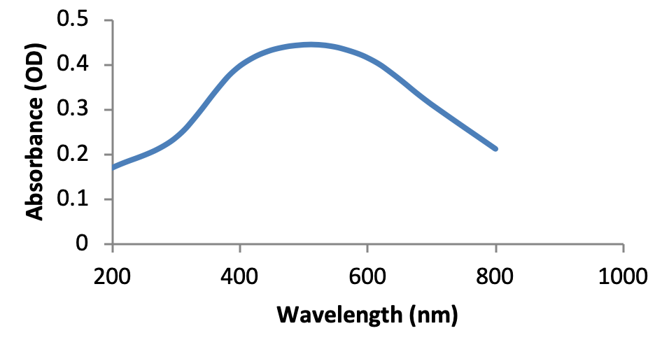
Figure 1:
UV-Vis Spectrum of SNPs biosynthesized using TCS of Chlorella vulgaris

Energy Dispersion X-Ray (EDX): Silver nanoparticles biosynthesized from TCS of Chlorella vulgaris were characterized using EDX at voltage of 40.0 KV and current of 350 µA. The intensity observed for TCS of Chlorella vulgaris SNPs ranged from 0.0001 – 0.5080 and content ranged from 0.0002 – 68.1197. The highest distinct peak (Ag) was observed in silver while elements such as Gold (Au), Arsenium (As), Lead (Pb), Vanadium (V), Potassium (K), Chromium (Cr), Titanium (Ti), and have zero intensity. The intensity and content are attributed to the reduction of silver ion to silver nitrate and silver nanoparticles formation.

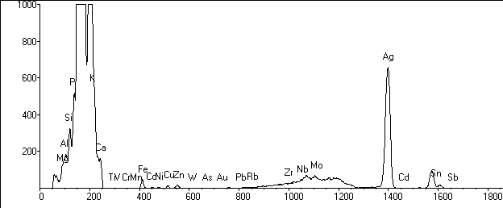
Figure 2:
EDX micrograph of the biosynthesized SNPs

Scanning Electron Microscopy (SEM): Scanning Electron Microscopy (SEM) was carried out in order to determine the morphological characteristics of the biosynthesized silver nanoparticles (Figure 3). The SEM confirmed the shape of the biosynthesized silver nanoparticles to be spherical and 10 nm in size.

Figure 3:
SEM micrograph of SNPs biosynthesized using TCS of Chlorella vulgaris

Thermogravimetry (TGA): Thermal stability in relative to weight of the biosynthesized silver nanoparticles was assessed using Differential Thermal Analysis - Thermogravimetry Analysis (DTA-TGA) (Figure 4). It was observed that dominant weight loss of SNPs of Chlorella vulgaris supernatant occurred in temperature region between 280˚C and 520˚C. There was almost no weight loss below 280˚C and above 520˚C. The weight loss can generally be attributed to the evaporation of water and organic components. The DTA plot displayed an intense endothermic peak between 240˚C and 600˚C.
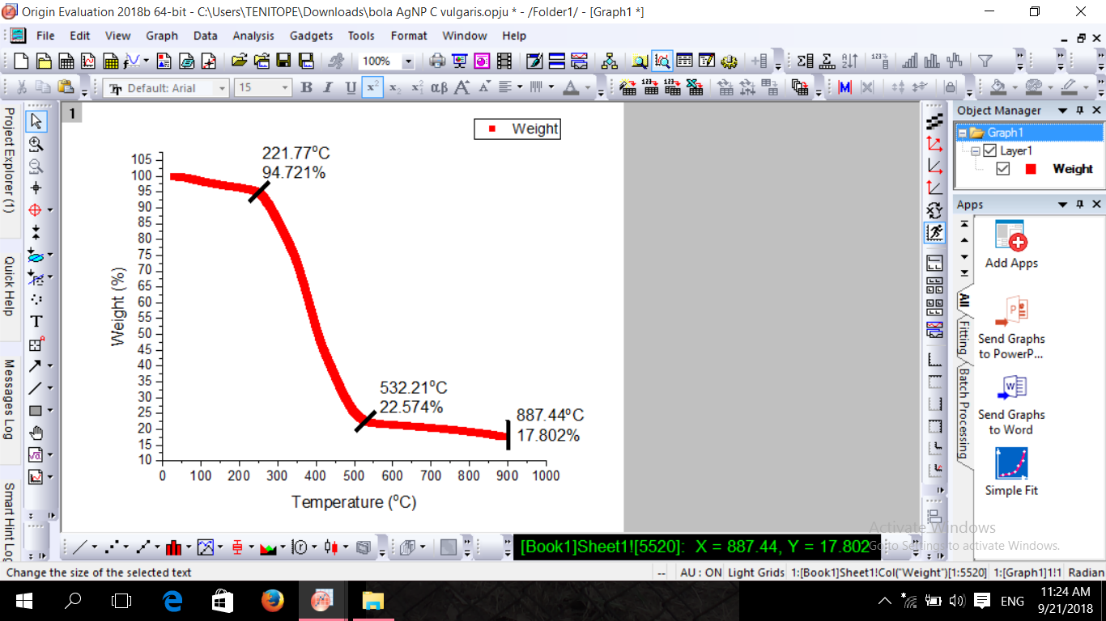
Figure 4:
TGA thermogram of biosynthesized silver nanoparticles from TCS of Chlorella vulgaris
Dynamic Light Scattering (DLS): The DLS size distribution analysis of the biosynthesized SNPs showed polydispersity of the TCSCvSNPs with average diameter of the particles size of 82.19 nm and 505.3 nm and the polydispersity index of 0.505 (Figure 5).

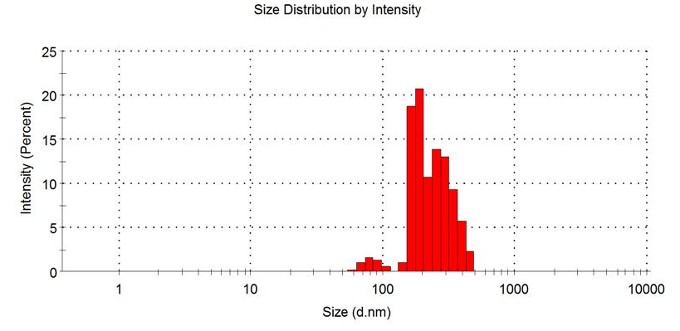
Figure 5:
Particle size distribution of the biosynthesized SNPs by DLS
Antibacterial Activity of CvTCSSNPs: CvTCSSNPs biosynthesized at different incubation time (24, 48 and 72 hours) had varied antagonistic activity against test pathogens as shown in Figure 6. Pseudomonas aeruginosa ATCC 27853 and Salmonella typhi ATCC 14028 (26.0 mm), Salmonella typhi ATCC 14028 (24.0 mm) and Citrobacter sp. (22.0 mm) was highly susceptible to CvTCSSNPs at 24, 48 and 72 hours respectively.

Antibiofilm activity of CvTCSSNPs
The antibiofilm activity of CvTCSSNPs shows reduction in the biofilm formation in all the test pathogens used thus confirming that the effectiveness of CvTCSSNPs against bacterial biofilm (Figure 7). Highest biofilm inhibition was observed in Bacillus sp. and Staphylococcus aureus ATCC 29213.

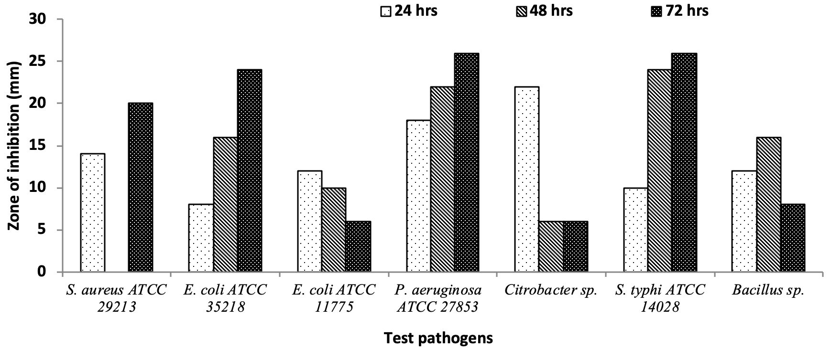
Figure 6:
The antibacterial activity of CvTCSSNPs biosynthesized at different incubation time against some test pathogens

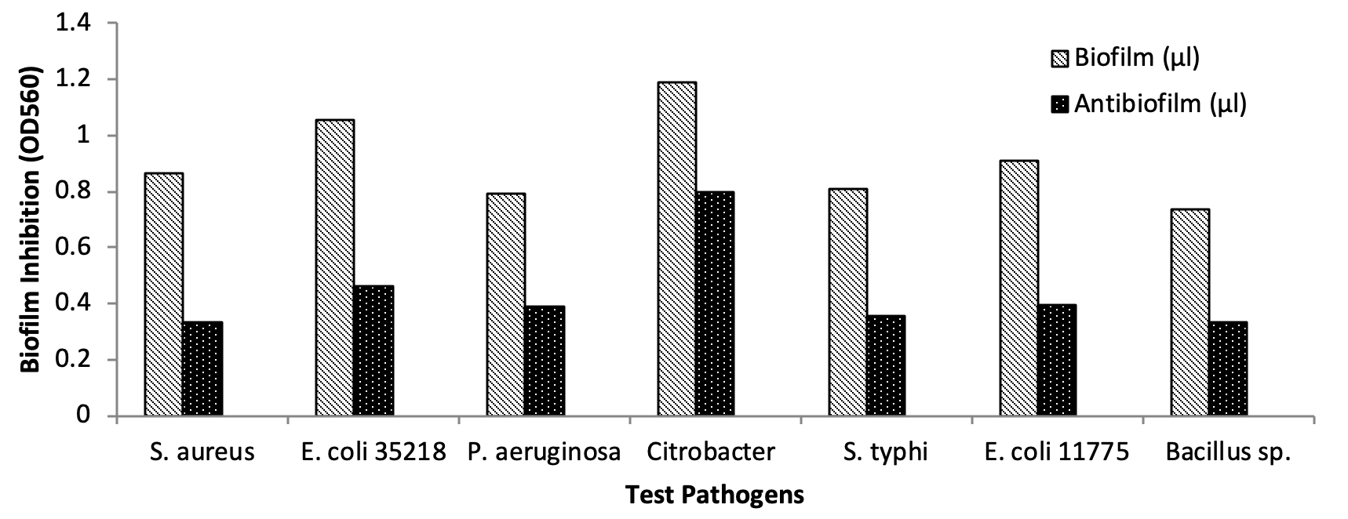
Figure 7:
Antibiofilm activity of the biosynthesized SNPs
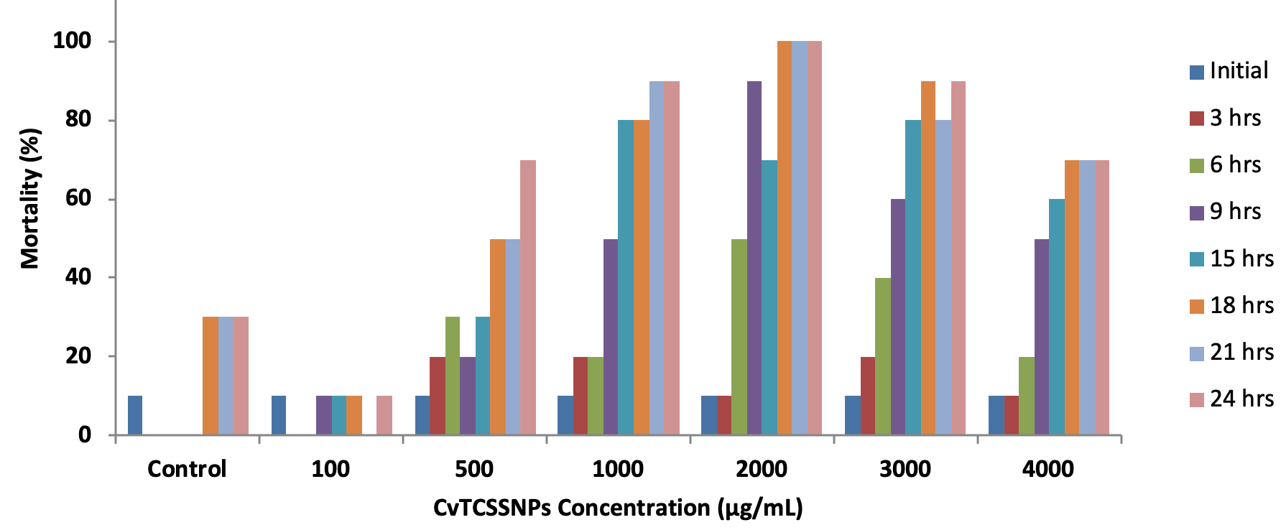
Figure 8:
Mortality rate of Artemia salina treated with TCSCvSNPs

Figure 9:
Effect of Physicochemical Parameters (a) effect of pH (b) effect of temperature (c) effect of CvTCS (d) effect of AgNO₃ on biosynthesis of CvTCSSNPs

Cytotoxicity of the biosynthesized CvTCSSNPs
The cytotoxicity effect of CvTCSSNPs against Artemia salina (brine shrimp) was carried out to check the toxicity level of the nanoparticles. The Artemia cytotoxicity test of CvTCSSNPs showed that mortality rate increased as concentration increased (Figure 8). The highest mortality rate occurred at lethal concentration of 2000 µg/mL.

Effect of Physicochemical Parameters on Biosynthesis of CvTCSSNPs
In SNPs biosynthesized using TCS of Chlorella vulgaris, the optimum production was observed at pH 10 (Figure 9a).
Temperature has a profound effect on SNPs biosynthesis. Optimum CvTCSSNPs biosynthesis was recorded at 37˚C (Figure 9b). This implies that temperature enhance rate at which silver nanoparticles are produced.
The UV-Vis spectra of the effect of different concentration (10 mL, 20 mL, and 40 mL) of CvTC on SNPs biosynthesized shows SPR peak at wavelength of 300 nm (Figure 8c). The highest peak was observed at sample concentration of 40 mL (300 nm) and lowest peak was observed at concentration of 10 mL (800 nm) respectively (Figure 9c). It was observed that the SNPs were more produced at sample concentration of 40 mL in CvTCSSNPs. This shows that the SNPs production increase as the concentration of reducing agent increases. The content of the sample in this case served as the reducing agent which bio-reduced the silver nitrate.
The effect of silver nitrate concentration on the synthesis of silver nanoparticles was evaluated. In CvTCSSNPs (Figure 9d). 5 mM was observed as the optimum silver nitrate concentration for the nanoparticles biosynthesis (Figure 8d).

DISCUSSION
Chlorella vulgaris supernatant (CvTCS) bio-reduced silver nitrate for silver nanoparticles formtion. Changes in colour from clear solution to chocolate brown indicate the formation of silvernanoparticles. This result is in agreement with the work of Jyoti et al. (2016) who observed colour change during Urtica dioica linn. leaves was used for silver nanoparticles biosynthesis. Rajeshkumar et al. (2017) observed colour change in the reaction mixture during silver nanoparticles biosynthesized using Padina tetrastromatica.
The UV-vis spectroscopy is a technique used to confirm the formation and stability of nanoparticles based on the optical properties of the nanoparticles and it serves as an indirect method used to determine the reduction of silver nitrate to silver nanoparticles in the aqueous solution. The optical property of silver nanoparticles is dependent on size and shape (He et al., 2000). Mie’s theory states that only a single surface plasmon resonance band is expected in the absorption spectra of spherical metal nanoparticles whereas anisotropic particles can give rise to two or more surface plasmon resonance bands, depending on the shape of the particles (Novak and Feldheim, 2000; Link and El-Sayed,2003). A single SPR peak was observed which suggests that the biosynthesized silver nanoparticles are spherical in shape and this was confirmed by the scanning electron micrograph. Broadening of the surface plasmon resonance can be attributed to the electron surface scattering which can be enhanced for small aggregates (Khan et al., 2017).
The EDX analysis revealed strong signals in the silver region and confirmed the formation of silver nanoparticles. There were other peaks for other elements suggesting that they are mixed precipitates present in CvTCS. This agrees with the work of Khan et al. (2017) observed similar reports when Ziziphus nummularia extract was used in biosynthesis of SNPs.
Raza et al. (2016) reported the effect of size and shape of silver nanoparticles on the antibacterial activity of the silver nanoparticles. He stated the effectiveness of nanoparticles is based on sizes and shapes. He reported that small size spherical silver nanoparticles are more active against microorganisms compared to larger spherical silver nanoparticles. Also that spherical silver nanoparticle is more effective against microbes than triangular shaped silver nanoparticles.
Size distribution of the silver nanoparticles synthesized using CvTCSSNPs was determined using Dynamic Light Scattering. This property indicates the suspensions of small particles where there is high surface area and significant particle – particle interactions. CvTCSSNPs was polydispersed. Monodispersed SNPs biosynthesized using Chlorella vulgaris was reported by Habibi-Pirkoohi and Soleimani (2017). Rai et al. (2009) reported that silver nanoparticles can act as potential antimicrobial agents against different microorganisms.
The antibacterial efficiency of silver nanoparticles has been reported to be sizes and shape dependent (Raza et al., 2016). The susceptibility of Pseudomonas aeruginosa ATCC 27853 to CvTCSSNPs is in agreement with the report of Raza et al. (2016) on the efficacy of silver nanoparticles of different sizes and shapes against Pseudomonas aeruginosa. Most of the test pathogens were susceptible to CvTCSSNPs.
Biofilms increase the antibiotic tolerance of microorganisms, making it very difficult to control infections. The penetrability potential and lethality deficiency of tobramycin and ciprofloxacin to biofilms formed by Pseudomonas sp. in a biofilm reactor has been reported (Walters and Parkin, 2009).
CvTCSSNPs are lethal to bacteria associated with a biofilm but their penetrability was not detected. It has been reported that higher concentrations of SNPs (100–1000 times) are necessary to kill microbes within biofilms as compared to concentrations needed to kill planktonic forms (Martinez-Gutierrez et al., 2013).
Ashkarran et al. (2011) reported that SNPs may have dual toxicity effects (high toxicity to bacteria and no/low toxicity (biocompatible) to human cells). SNPs covering the surfaces can provide great potential for prevention and treatment of these infections related to biofilm formation.
From the result, it was observed that the increase in mortality rate is dose dependent and this is in agreement with the work of Vijayan et al. (2014) on silver nanoparticles synthesized from the extract of seaweed Turbinaria conoides.
It has been reported that pH of reaction mixture plays a very important role in the synthesis of nanoparticles (Rajeshkumar et al., 2017). Increase in nanoparticles biosynthesis at pH 10 is in agreement with the report of Sanghi and Verma (2009) that the addition of an alkaline ion in the reaction mixture is necessary to carry out the reduction of metal ions.
The SPR peaks observed was suspected to have two distinct peaks indicating possibility of formation of non-spherical SNPs. This is in agreement with the work of Khan et al. (2017) who reported that sizes and shapes of peaks change as concentration of silver solution changes and that maximum absorbance of SNPs is dependent on silver nitrate concentration present. Physicochemical parameters had profound effect on SNPs biosynthesized using TCS of Chlorella vulgaris as a bio-reducing agent.
In conclusion, silver nanoparticles were biosynthesized using metabolite of Chlorella vulgaris. The SNPs were spherical in shape and 10 nm in size. It was thermally stable and exhibited antibacterial and anti-biofilm activities.

References

Abou El-Nour K.M.M., Eftaiha A., Al-Warthan A., Ammar R.A.A. (2010). Synthesis and Applications of Silver Nanoparticles, Arabian J. Chem. 3, 135-140.
Alves M.J., Isabel C.F., Ferreira R., Lourenço I., Costa E., Martins A., Pintado M. (2014). Wild Mushroom Extracts as Inhibitors of Bacterial Biofilm Formation. Pathog. 667-679.
Ashkarran A.A. (2011). Metal and metal oxide nanostructures prepared by electrical arc discharge method in liquids, J. Cluster Sci. 22, 233.
Ashokkumar T., Vijayaraghavan K. (2016). Brown seaweed-mediated biosynthesis of gold nanoparticles. J.Environ. Biotechnol. Res. 2, 45-50.
Dakal T.C., Kumar A., Majumdar R., Yadav V. (2016). Mechanistic basis of antimicrobial actions of silver nanoparticles, Front. Microbiol. 7,1831.
Dumur F., Eddy A.G., Denis D., Didier B., Cedric G., Mayer, R. (2011). Controlled spontaneous generation of gold nanoparticles assisted by dual reducing and capping agents, Gold Bull. 44, 119-137.
Finney D.J. (1971). Probit analysis, 3rd ed. Cambridge University Press, Cambridge, United Kingdom.
Habibi-Pirkoohi M., Soleimani M. (2017). Biosynthesis of silver nanoparticles using Chlorella vulgaris and evaluation of the antibacterial efficacy against Staphylococcus aureus, Avicenna J. Med. Biotechnol. 9:120-125.
He R., Qian X., Yin J. (2000). Preparation of polychrome silver nanoparticles in different solvents, J. Mat. Chem. 12, 3783–3786.
Jyoti K., Baunthiyal M., Singh A. (2016). Characterization of Silver Nanoparticles synthesized using Urtica dioica Linn. Leaves and their synergistic effects with antibiotics. J. Rad. Res. Appl. Sci. 9: 217-227.
Khan I., Ibrahim A.A.M., Sohail M., Qurashi A. (2017). Sono-chemical assisted synthesis of RGO / ZnO Nanowire Arrays for Photoelectrochemical Water Splitting,Ultrasonic Sonochem. 37, 669–675.
Link S., El-Sayed M.A. Optical properties and ultrafast dynamics of metallic nanocrystals, Annual Rev. Physical Chem. 54, 331–366.
Lloyd J.R., Oremland R.S. (2006): Microbial transformations of arsenic in the environment: from soda lakes to aquifers, Elements 2:85-90.
Martinez-Gutierrez F., Boegli L., Agostinho A., Sánchez E.M., Bach H., Ruiz F., James G. (2013). Anti-biofilm activity of silver nanoparticles against different microorganisms, Biofoul. 29:651-660.
McLaughlin C.J., Chang L.J., Smith DL. Simple bench-top bioassays (brine shrimps and potato discs) for the discovery of plant anti-tumor compounds. In: Human medicinal agent from plants. Inghorn, A.D., Balandrin, M.F. (Eds) ACS Symposium. 534 American Chemical Society, Washington DC. Pp. 112-137.
Novak J.P., Feldheim D.L. (2000). Assembly of phenylacetylene bridged silver and gold nanoparticle arrays, J. American Chem. Soci. 122, 3979–3980.
Pal S., Tak Y.K., Song, J.M. (2007). Does the Antibacterial Activity of Silver Nanoparticles Depend on the Shape of the Nanoparticle? A Study of the Gram-Negative Bacterium Escherichia coli. Appl. Environ. Microbiol. 73, 1712 –1720.
Rai M., Yadav A., Gade A. (2009): Silver nanoparticles as a new generation of antimicrobials, Biotechnol. Adv. 27, 76 83.
Rajabi S., Ramazani A., Hamidi M., Naji T. (2015): Artemia salina as a model organism in toxicity assessment of nanoparticles, Dura J. Pharmaceu. Sci. 23, 20.
Rajeshkumar S., Malarkodi C., Venkat-Kumar S. (2017). Synthesis and Characterization of Silver Nanoparticles from Marine Brown Seaweed and Its Antifungal Efficiency against Clinical Fungal Pathogens, Asian J. Pharm. Clin. Res. 10, 190 - 193.
Raza M.A., Kanwal Z., Rauf A., Sabri A.N., Riaz S., Naseem, S. (2016). Size and Shape-Dependent Antibacterial Studies of Silver Nanoparticles Synthesized by Wet Chemical Routes, Nanomaterial 6, 74.
Sabri M.A., Umer A., Awan G.H. (2016): Selection of suitable biological method for the synthesis of silver nanoparticles, Nanomat. Nanotechnol. 6; 6(29), 1-20.
Sanghi R., Verma P. (2009) Biomimetic synthesis and characterization of protein capped silver nanoparticles, Biores. Technol. 100, 501–504.
Sosa I.O., Noguez C., Barrera R.G. (2003). Optical properties of metal nanoparticles with arbitrary shapes, J. Phy. Chem. 107(26), 6269 - 6275.
Templeton A.C., Wuelfing W.P., Murray R.W. (2000). Monolayer-protected cluster molecules, Acc. Chem. Res. 33, 27-36.
Vijayan S.R., Santhiyagu P., Singamuthu M., Ahila N.K.,
Jayaraman R., Ethiraj K. (2014). Synthesis and characterization of silver and gold nanoparticles using aqueous extract of seaweed, Turbinaria conoides, and their antimicrofouling activity, The Scientific Wrld. J. 1-10.
Walters G., Parkin I.P. (2009). The incorporation of noble metal nanoparticles into host matrix thin films: synthesis, characterization and applications, J. Mat. Chem.19, 574-590.
Wang L., Hu C., Shao L. (2017). The antimicrobial activity of nanoparticles: present situation and prospects for the future, Inter. J. Nanomed. 12, 1227-1249.
Yadav R., Satyanarayanan T., Kotwal S., Rayalu S. (2011): Enhanced carbonation reaction using chitosan-based carbonic anhydrase nanoparticles, Curr. Sci. 100, 520-524.
Yamamoto M., Fujishita M., Hirata A., Kawano S. (2004): Regeneration and maturation of daughter cell walls in the autospore-forming green alga Chlorella vulgaris (Chlorophyta, Trebouxiophyceae), J. Plant Rsc. 117, 257264.
Zaidi A.A., Malik A., Mushtaq K., Ruizhe F. (2018): Progress of microalgal biodiesel research in Pakistan, J. Plant Sci. Curr. Res. 2, 4.

